FORNAX™ ePlanCheck Rule
Rule Information
Rule ID | SSW 2.1.7 (c)
Rule Name | Minimum Depth of Manhole
Chapter | 2 Sewerage Works
Section | 2.1 Design Requirements for Sewers
Handbook | Code of Practice on Sewerage and Sanitary Works  Addendum No. 2 - Nov 2004

Rule Description
2.1.7 Sewer Manhole
- The minimum depth of manholes, measured from the top of their covers to their inverts, shall be 1.5 metres.

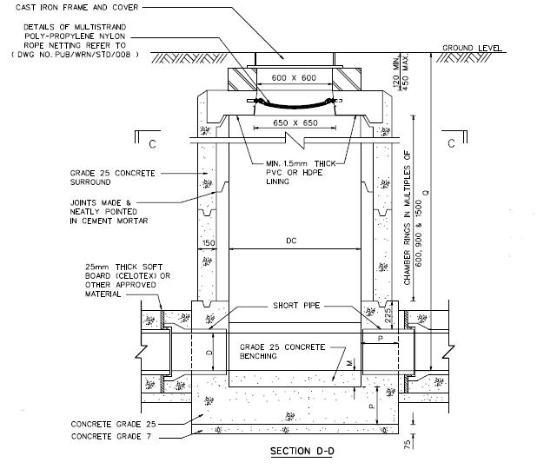
Figure 01: Precast Manhole
DEPARTMENT’S STANDARD DETAILS OF MANHOLES

Rule Interpretation
- This rule checks for the minimum depth of manhole.
- The measurement starts at the top of manhole cover to the inverted level of the pipe. (Figure 01).
- Minimum depth of Manhole is 1500 mm.
MANHOLE TOP COVER
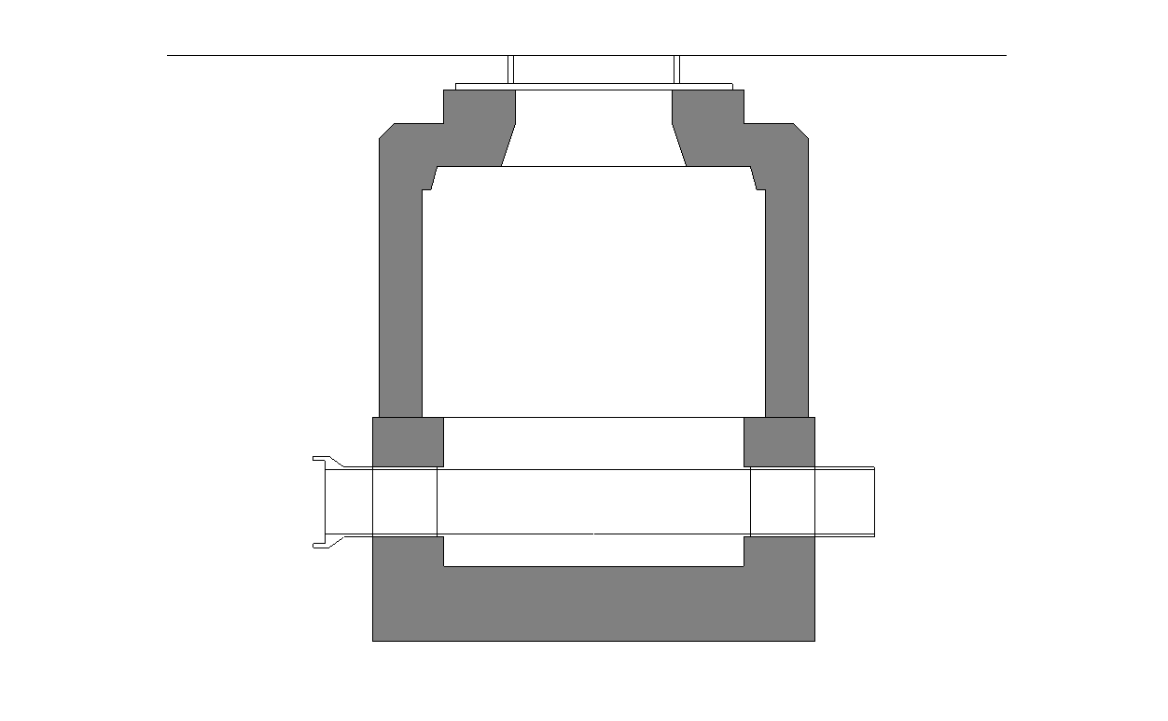
MANHOLE DEPTH

PIPE
FIGURE 01
SECTION VIEW
INVERT LEVEL OF PIPE

Rule Scenario

Scenario 01 - Compliant
Requirement | Minimum 1500 mm depth from the top of the cover to the invert level of the pipe
Description | The manhole depth is 1700 mm
MANHOLE TOP COVER
MANHOLE DEPTH
1700 mm
MANHOLE SECTION
FIGURE SCENARIO

PIPE
INVERT LEVEL OF PIPE

Scenario 01 - Non-Compliant
Requirement | Minimum 1500 mm depth from the top of the cover to the invert level of the pipe
Description | The manhole depth is 1400 mm
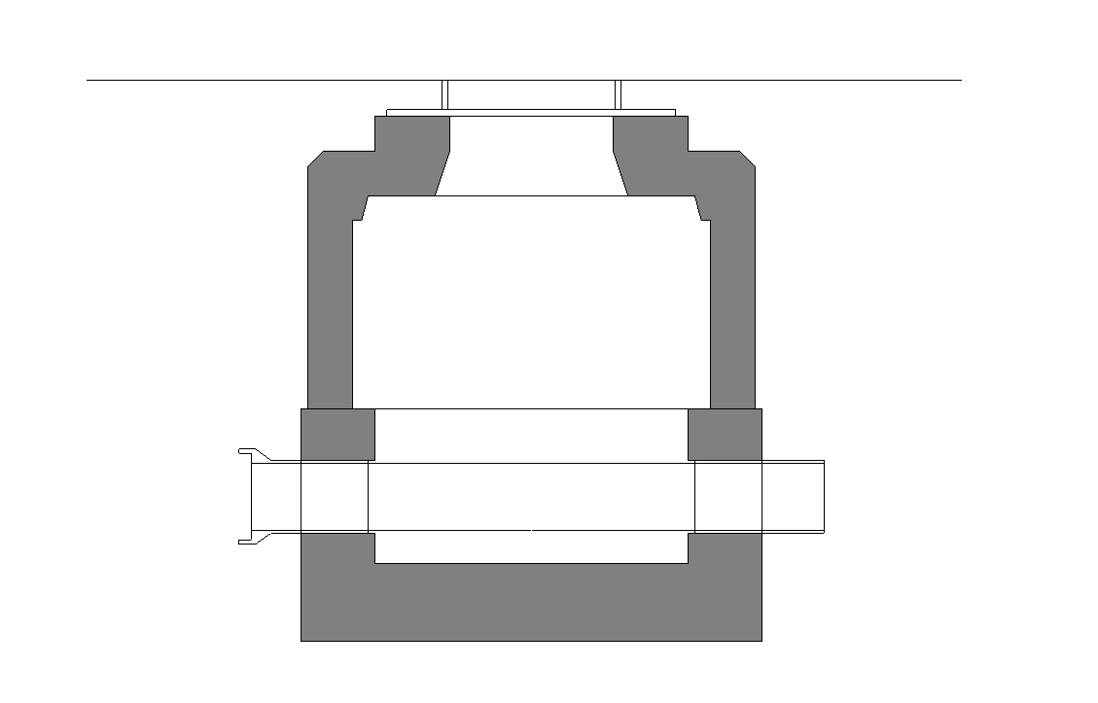
MANHOLE DEPTH
1400 mm
MANHOLE SECTION
FIGURE SCENARIO

PIPE
MANHOLE TOP COVER
INVERT LEVEL OF PIPE

Request For Information
- There is discrepancy between the Rule Description and Standard Drawing. Which should be govern? Please check the figures below.
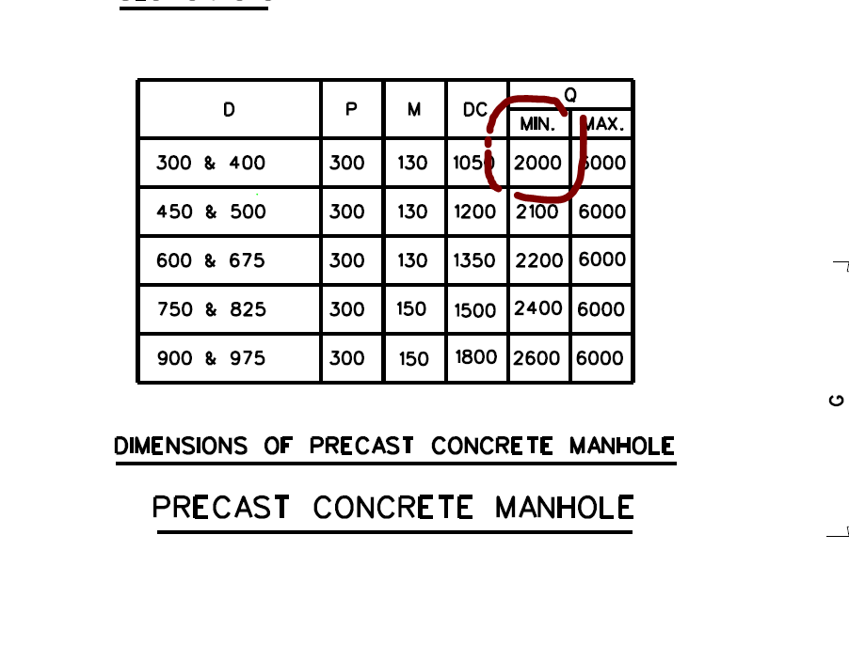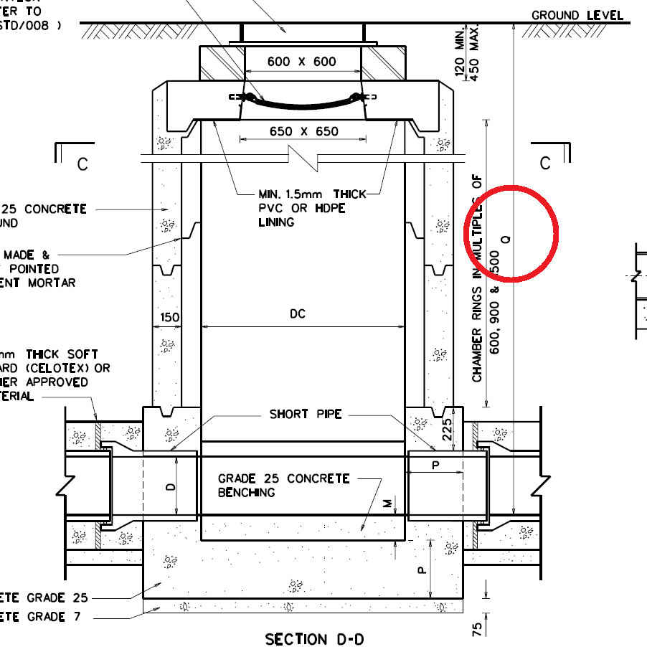

Model PreCheck

Required Elements | Required Attributes
DistributionChamberElement | IfcName contains “Sewer Manhole”
PipeSegment | IfcDescription contains “Public Sewer”

Rule Parameters

System Type
Cold Water
Hot Water
 | Sanitary
 | Sewerage | 
Vent

Element Type 1
State | Type | Property | Operator | Value
Include | DistributionChamberElement | Name | Contains | Sewer Manhole
Exclude |  | Any | Match | <User define>
 |  |  | N.A. | N.A.

Element Type 2
State | Type | Property | Operator | Value
Include | PipeSegment | IfcDescription | Contains | Public sewer
Exclude |  | Any | Match | <User define>
 |  |  | N.A. | N.A.

Element Type 1 Condition
Minimum depth is | 1500 | mm from the top of cover to
Inverted level of Element Type 2.

Result Messages
- 2.1.7 (a) Manhole Standard Material
  - Non-compliant (TotalResultNumeric)
    - BuildingStorey (TotalResultPerFloorNumeric)
    - ElementType2Name depth: (NumericValue) mm; ElementType1Name depth is below minimum
  - Compliant (TotalResultNumeric)
    - BuildingStorey (TotalResultPerFloorNumeric)
    - ElementType1Name depth: (NumericValue) mm; ElementType1Name depth complied with minimum 1500 mm
  - Attention (TotalResultNumeric)
    - BuildingStorey (TotalResultPerFloorNumeric)
    - ElementType2Value is not found.

Sample Result Messages
- 2.1.7 (c) Minimum Depth of Manhole
  - Non-Compliant (1)
    - Level 1 (1)
    - Manhole Depth: 1400 mm; Manhole depth is below minimum
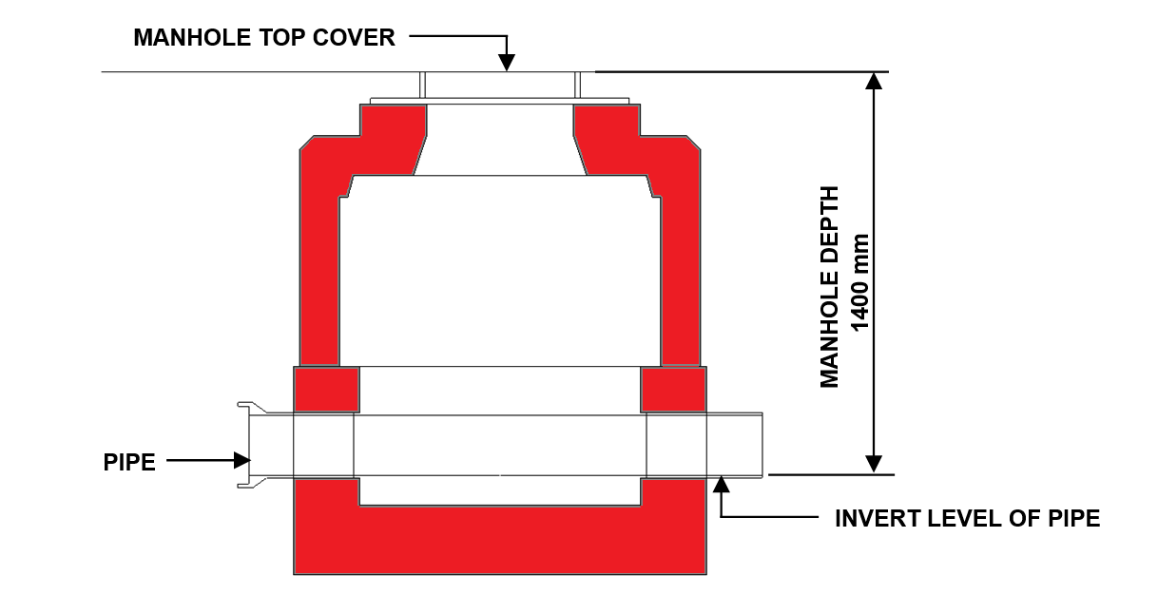

  - Compliant (1)
    - Level 1 (1)
    - Manhole Depth: 1700 mm; Manhole depth complied the minimum 1500 mm
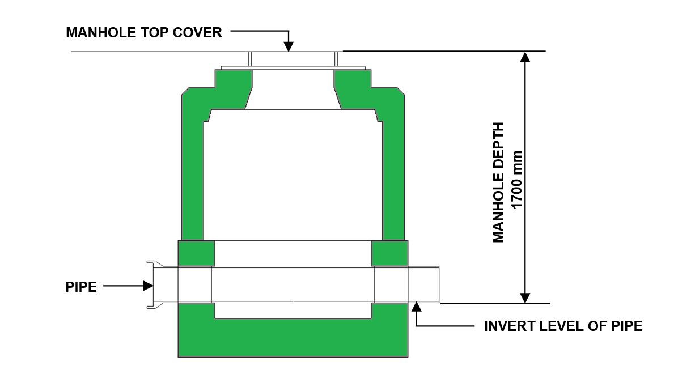

  - Attention (0)
    - Level 1 (0)
    - Public Sewer is not found

Sample Result Model Views
- 2.1.7 (c) Minimum Depth of Manhole
  - Non-Compliant
    - Side View.
    - Manhole is displayed.
    - All other elements are translucent except manhole.
  - Compliant
    - Side View.
    - Manhole is displayed.
    - All other elements are translucent except manhole.

Testing Scenario Notes
- Scenario 01 - Compliant
- Level 01
- The manhole depth is 1.4 meters
- Scenario 01 – Non Compliant
- Level 01
- The manhole depth is 1.7 meters

Model:
SSW 2.1.7 (c) Compliant.ifc
SSW 2.1.7 (c) Non-Compliant.ifc

Modelling Guideline
- Specify IfcName and IfcExportAs containing “Sewer Manhole” for relevant DistributionChamberElement.
- Specify IfcDescription containing “Public Sewer” for relevant PipeSegment.

Specification Log
RA | Kawther B tabernero
Last edit date | 8 November 2018
ePC version
Updates | - V1

